1. On the flowering plant diagram below, the structure labeled "a" is a
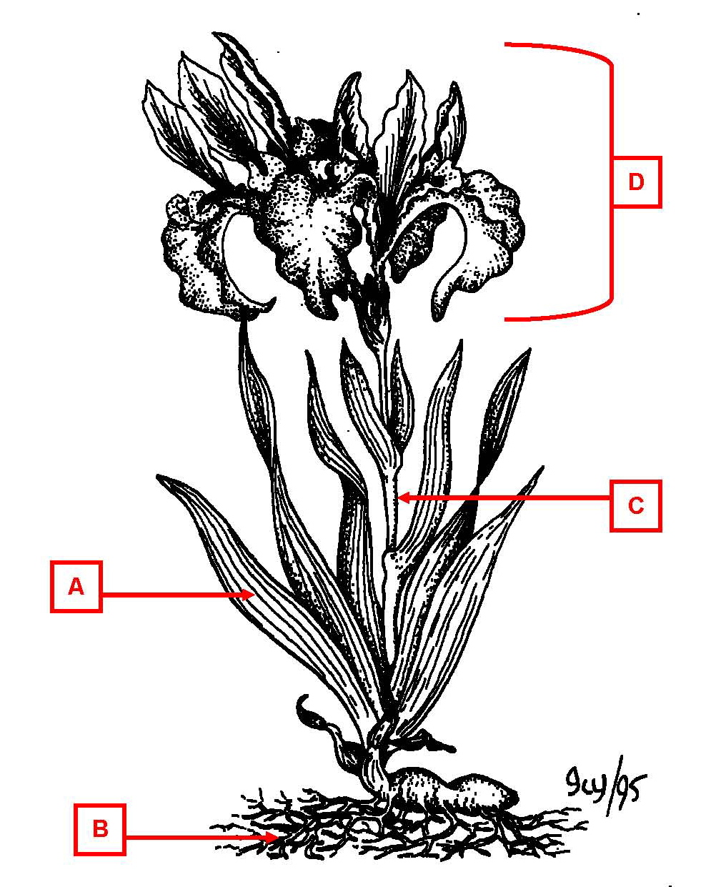

*a. leaf
b. stem
c. strobilus
d. root

2. On the flowering plant diagram below, the structure labeled "b" is a

a. leaf
b. stem
c. strobilus
*d. root

3. On the flowering plant diagram below, the structure labeled "c" is a

a. leaf
*b. stem
c. strobilus
d. root

4. On the flowering plant diagram below, the structure labeled "d" is a

a. leaf
b. stem
*c. strobilus
d. root

5. On the diagram of a flower, the structure labeled "a" is the
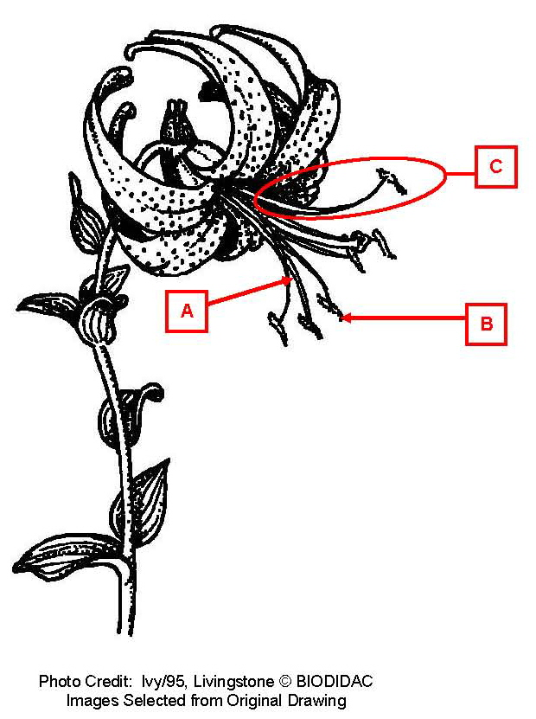

a. anther
*b. filament
c. stamen
d. style

6. On the diagram of a flower, the structure labeled "b" is the

*a. anther
b. filament
c. stamen
d. style

7. On the diagram of a flower, the structure labeled "c" is the

a. anther
b. filament
*c. stamen
d. style

8. On the diagram of an anther, the structure labeled "a" is the
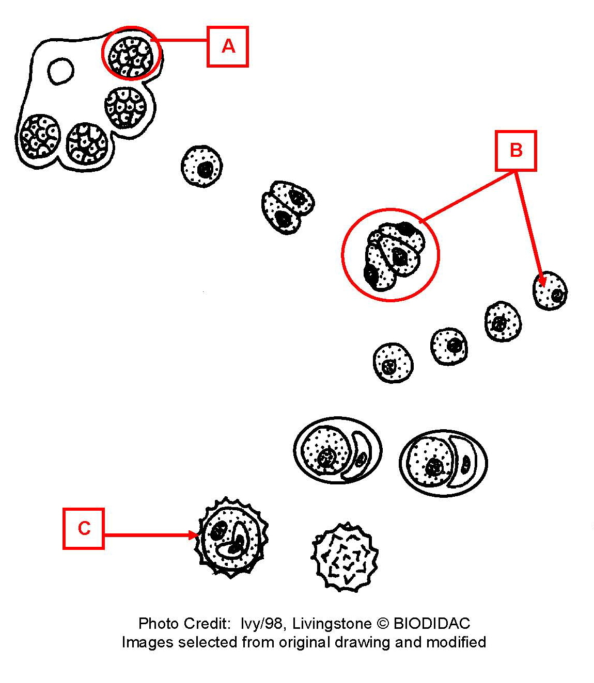

a. male gametophyte (pollen)
*b. microsporangium
c. microspore

9. On the diagram of an anther, the structure labeled "b" is the

a. male gametophyte (pollen)
b. microsporangium
*c. microspore

10. On the diagram of an anther, the structure labeled "c" is the

*a. male gametophyte (pollen)
b. microsporangium
c. microspore

11. On the diagram of a flower, the structure labeled "a" is the
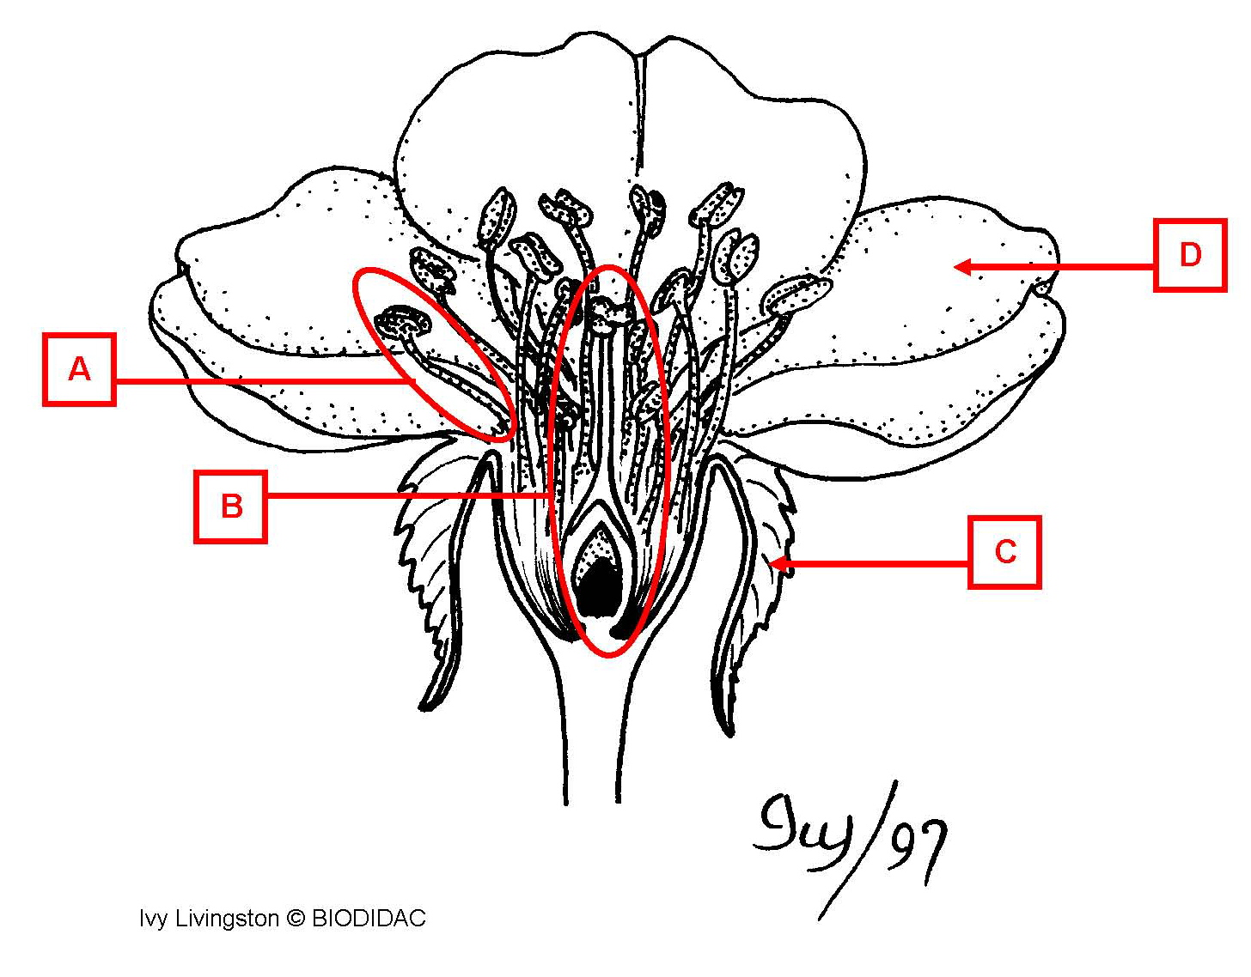

a. megasporophyll
*b. microsporophyll
c. petal
d. sepal

12. On the diagram of a flower, the structure labeled "b" is the

*a. megasporophyll
b. microsporophyll
c. petal
d. sepal

13. On the diagram of a flower, the structure labeled "c" is the

a. megasporophyll
b. microsporophyll
c. petal
*d. sepal

14. On the diagram of a flower, the structure labeled "d" is the

a. megasporophyll
b. microsporophyll
*c. petal
d. sepal

15. On the diagram of a carpel, the structure labeled "a" is the
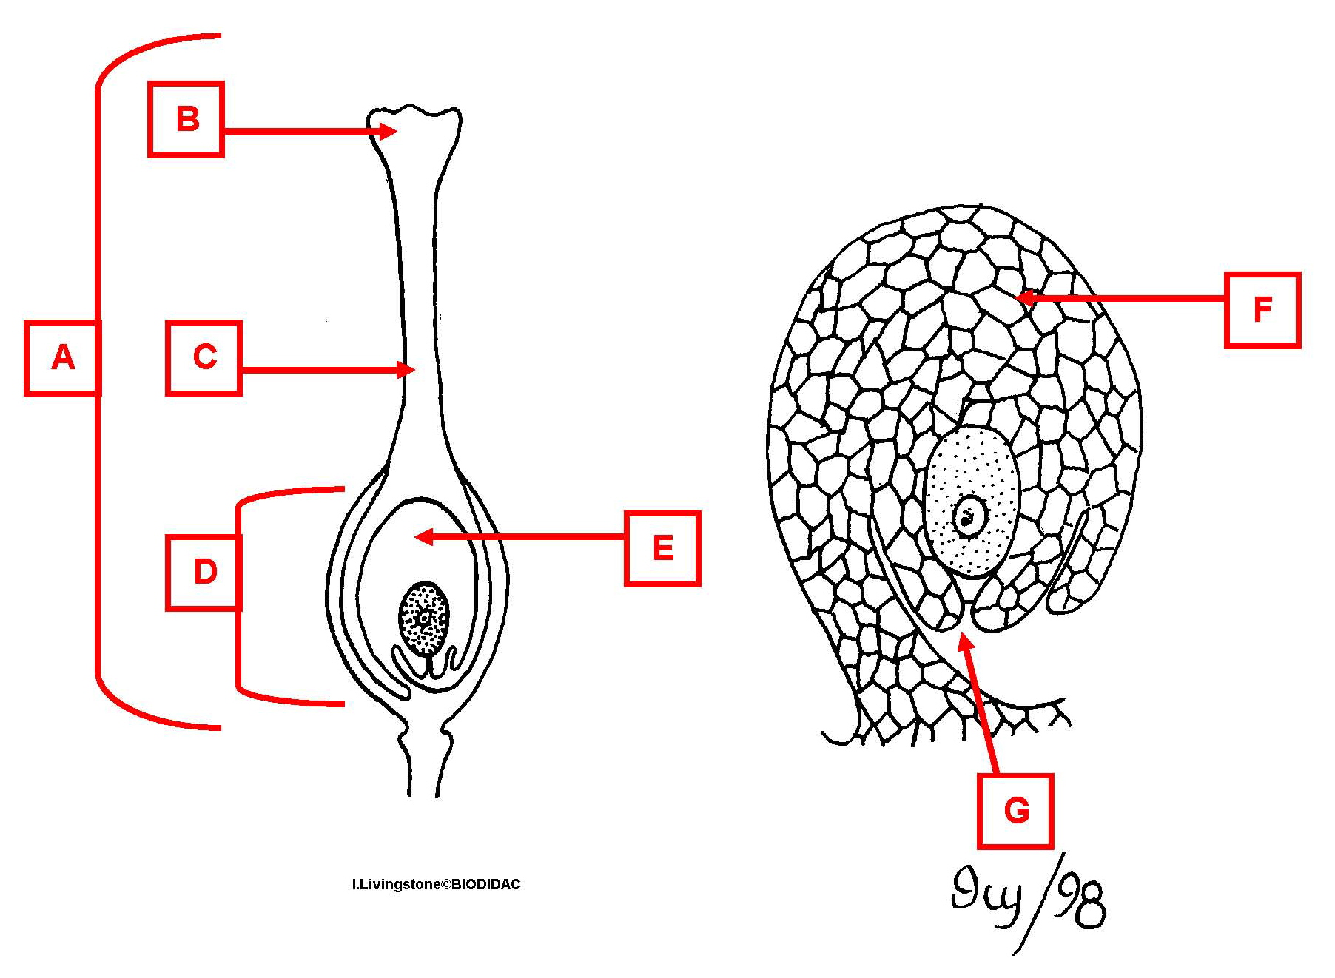

a. integument
b. micropyle
c. ovary
d. ovule
*e. pistil
f. stigma
g. style

16. On the diagram of a carpel, the structure labeled "b" is the

a. integument
b. micropyle
c. ovary
d. ovule
e. pistil
*f. stigma
g. style

17. On the diagram of a carpel, the structure labeled "c" is the

a. integument
b. micropyle
c. ovary
d. ovule
e. pistil
f. stigma
*g. style

18. On the diagram of a carpel, the structure labeled "d" is the

a. integument
b. micropyle
*c. ovary
d. ovule
e. pistil
f. stigma
g. style

19. On the diagram of a carpel, the structure labeled "e" is the

a. integument
b. micropyle
c. ovary
*d. ovule
e. pistil
f. stigma
g. style

20. On the diagram of a carpel, the structure labeled "f" is the

*a. integument
b. micropyle
c. ovary
d. ovule
e. pistil
f. stigma
g. style

21. On the diagram of a carpel, the structure labeled "g" is the

a. integument
*b. micropyle
c. ovary
d. ovule
e. pistil
f. stigma
g. style

22. On the diagram of a flowering plant seed, the structure labeled "a" is the
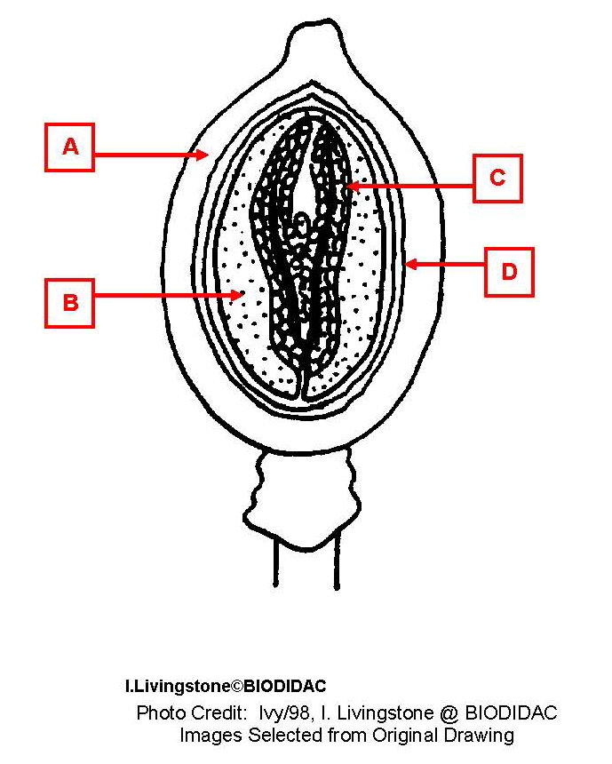

a. embryo
b. endosperm
*c. fruit
d. seed coat

23. On the diagram of a flowering plant seed, the structure labeled "b" is the

a. embryo
*b. endosperm
c. fruit
d. seed coat

24. On the diagram of a flowering plant seed, the structure labeled "c" is the

*a. embryo
b. endosperm
c. fruit
d. seed coat

26. On the diagram of a flowering plant seed, the structure labeled "d" is the

a. embryo
b. endosperm
c. fruit
*d. seed coat

27. On the diagram of the bean seed, the structure labeled "a" is the
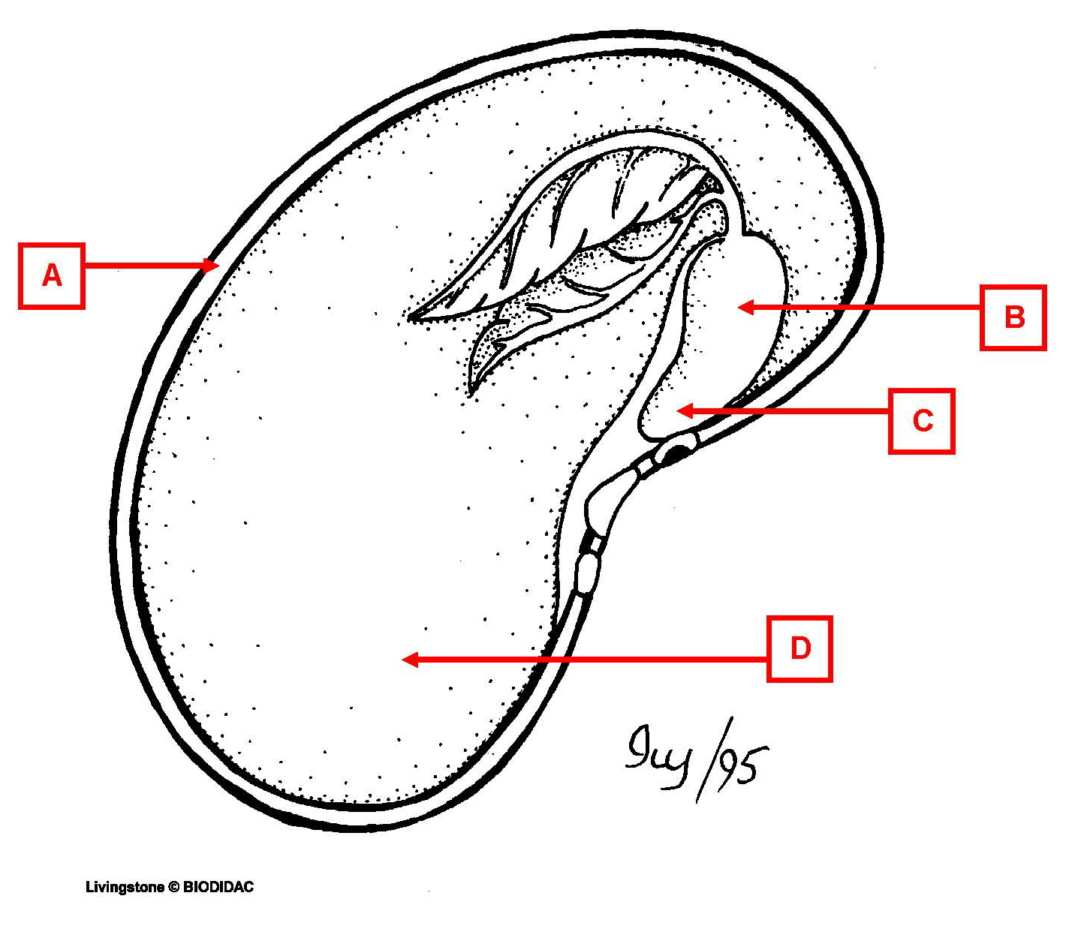

a. cotyledon
b. hypocotyl
c. radicle
*d. seed coat

28. On the diagram of the bean seed, the structure labeled "b" is the

a. cotyledon
*b. hypocotyl
c. radicle
d. seed coat

29. On the diagram of the bean seed, the structure labeled "c" is the

a. cotyledon
b. hypocotyl
*c. radicle
d. seed coat

30. On the diagram of the bean seed, the structure labeled "d" is the

*a. cotyledon
b. hypocotyl
c. radicle
d. seed coat

31. On the diagram of the bean seedling, the structure labeled "a" is the
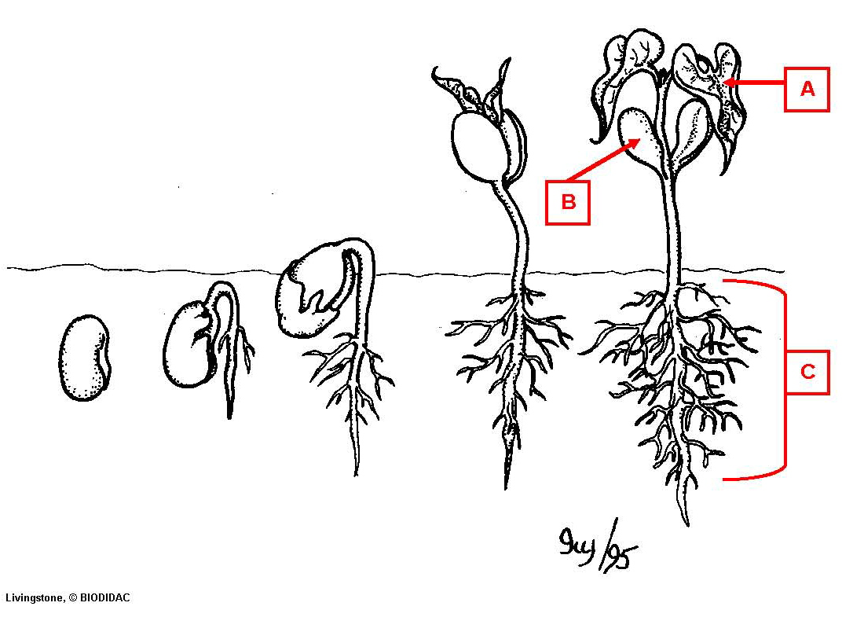

a. cotyledon
b. hypocotyl
c. roots
*d. true leaf

32. On the diagram of the bean seedling, the structure labeled "b" is the

*a. cotyledon
b. hypocotyl
c. roots
d. true leaf

33. On the diagram of the bean seedling, the structure labeled "c" is the

a. cotyledon
b. hypocotyl
*c. roots
d. true leaf

